CASE STUDY REPORT

A Case Study on Leaving a Computer Screen Unlocked at the Workplace

1) Introduction
In today’s IT industry, software engineers work with highly sensitive data such as source code, client information, and confidential project documents. Protecting this data is a professional and ethical responsibility. Software Configuration Management (SCM) helps in managing and controlling such data, and version control is one of its most important components.
This case study discusses a workplace situation where a software engineer leaves their computer screen unlocked while stepping away. Although this action is unintentional, it creates serious ethical and security risks. The study focuses on how version control helps in managing such risks and compares how such a situation would have been handled earlier and how it is managed today.

2) Description of the Case Study
In the given scenario, a software engineer working in an IT company steps away from their desk for a short break but forgets to lock their computer screen. The system provides access to confidential project files, source code repositories, client data, and internal communication tools.
A colleague notices that the system is unlocked and unattended. This situation immediately raises concerns because anyone passing by could access or misuse the information available on the system. Even though the engineer did not intend to cause harm, the carelessness involved poses a threat to the organization.

3) Ethical and Security Concerns in the Case
Leaving a computer screen unlocked may seem like a small mistake, but in a professional environment it can have serious consequences.
Some major concerns highlighted by this case are:
- Unauthorized access to sensitive company and client information
- Possibility of accidental or intentional modification of source code
- Risk of copying or deleting important project files
- Difficulty in identifying responsibility if a security breach occurs

4) Version Control in the Case Study

A] Objectives of Version Control
The main objective of version control is to manage changes made to source code and project files in a systematic way. It helps developers keep track of different versions of files and ensures that important data is not lost due to mistakes or unauthorized actions.
The objectives of version control include:
- Maintaining a complete history of changes
- Identifying who made a change and when
- Allowing multiple developers to work on the same project
- Enabling recovery of previous versions when required

B] Role of Version Control in the Case Study
In the given case study, leaving the computer screen unlocked creates a risk that someone may access or modify project files without permission. Version control helps reduce this risk by ensuring that every change made to files is recorded.
If someone modifies the source code using the unlocked system:
- The change is logged with user details and timestamp
- Unexpected or suspicious changes can be identified
- The team can trace the change back to the responsible user

C] Version Control: Earlier vs Modern Approach
Earlier Approach:
- Files were saved manually with different names
- No proper tracking of who changed what
- Changes made on an unlocked system could go unnoticed
- Recovering lost or modified files was difficult
Modern Approach:
- All changes are automatically tracked
- Each change is linked to a specific user
- Unauthorized or suspicious changes are easily detected
- Previous versions can be restored quickly

5) Build Management in the Case Study
A] Objectives of Build Management
The main objective of build management is to convert source code into a working software build in a controlled and repeatable manner. It ensures that the software is built using correct source code, proper dependencies, and standard configurations.
The objectives of build management include:
- Generating consistent and reliable software builds
- Avoiding build failures due to misconfiguration
- Maintaining records of build processes
- Ensuring that builds are created only from approved code

B] Role of Build Management in the Case Study
In this case study, leaving the computer screen unlocked can directly affect the build process. Since the system has access to build scripts and configuration files, an unauthorized person could unintentionally modify them. Even a small change in a build file can cause the entire build to fail.
Build management helps handle this situation by ensuring that:
- Builds are generated only from verified source code
- Any change affecting the build is logged and traceable
- Faulty builds can be identified and stopped early

C] Build Management: Earlier vs Modern Approach
Earlier Approach:
- Builds were done manually on individual systems
- Build settings differed from system to system
- Changes made on an unlocked system could break builds easily
- No clear way to find out what caused a build failure

Modern Approach:
- Builds are automated using standard build tools
- Only approved source code is used for builds
- Build failures can be traced back to specific changes
- Unauthorized changes are detected quickly

6) Release Management in the Case Study

A] Objectives of Release Management
Release management focuses on delivering the right version of software to users or clients. It ensures that only tested, stable, and approved builds are released.
The main objectives of release management are:
- Preventing the release of faulty or incomplete software
- Maintaining proper documentation of releases
- Protecting the organization’s reputation and client trust

B] Role of Release Management in the Case Study
In the given scenario, unauthorized changes made through an unlocked system could accidentally become part of a release. This could cause serious problems once the software is delivered to users.
Release management prevents this by:
- Allowing only approved builds to be released
- Restricting access to release pipelines
- Ensuring that releases follow a defined approval process

C] Release Management: Earlier vs Modern Approach
Earlier Approach:
- Releases were done manually without strict checks
- Unauthorized changes could reach the final release
- Limited documentation of released versions
- High risk to client trust if errors occurred
Modern Approach:
- Only tested and approved builds are released
- Access to release process is restricted
- Release versions are properly labeled and documented
- Unauthorized changes cannot be released easily

7) Change Management in the Case Study

A] Objectives of Change Management
Change management ensures that all changes made to software are properly requested, reviewed, approved, and documented. It brings discipline and structure to the development process.
The objectives of change management include:
- Preventing unauthorized or unnecessary changes
- Maintaining documentation for every change
- Ensuring project stability and quality

B] Role of Change Management in the Case Study
In this case study, if someone modifies files using the unlocked system, those changes may not follow proper procedures. Change management helps detect and control such situations.
It ensures that:
- All changes require formal approval
- Unauthorized changes are identified quickly
- Corrective actions such as rollback can be taken

C] Change Management: Earlier vs Modern Approach
Earlier Approach:
- Changes were made directly without approval
- No proper documentation of changes
- Difficult to identify who made a change
- High chance of confusion and instability
Modern Approach:
- All changes require proper approval
- Changes are documented and tracked
- Unauthorized changes are detected and reverted
- Better control and project stability

8) Earlier Scenario Without Proper SCM
In earlier software development environments, SCM practices were weak or manual. If this case occurred earlier:
- Changes could be made without any tracking
- Builds could break without clear reasons
- Faulty releases might reach customers
- Accountability would be very difficult to establish
Lack of proper version control, build automation, release checks, and change approval made systems more vulnerable to human mistakes.

9) Modern SCM Handling of the Case
In modern software development, SCM tools integrate version control, build management, release management, and change management.
Because of this:
- All changes are tracked and traceable
- Builds are automated and reproducible
- Releases are controlled and documented
- Unauthorized changes are easily detected
This integration significantly reduces the impact of negligence such as leaving a computer screen unlocked.

10) Preventive Measures Suggested
Based on this case study, organizations should:
- Enforce automatic screen lock policies
- Train employees on professional ethics
- Use strong authentication for SCM tools
- Regularly monitor SCM activity logs

11) Conclusion
This case study shows that leaving a computer screen unlocked at the workplace can create serious ethical and security risks. Software Configuration Management plays a crucial role in controlling such risks through version control, build management, release management, and change management.
Earlier systems were not capable of handling such situations effectively, but modern SCM practices provide better control, traceability, and security. However, technical tools alone are not enough. Responsible behavior and ethical awareness are equally important to ensure safe and effective software development.

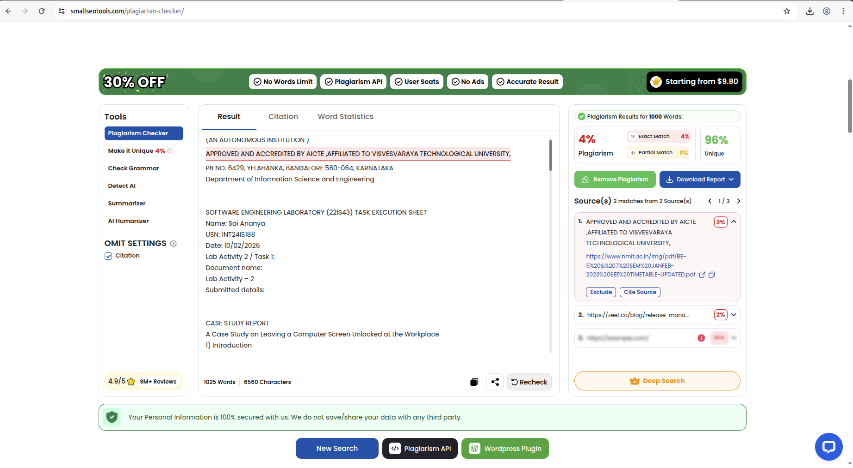
12) Plagiarism Report

